**CONTRACTOR’S OBLIGATIONS TO START WORKING AT YARA**

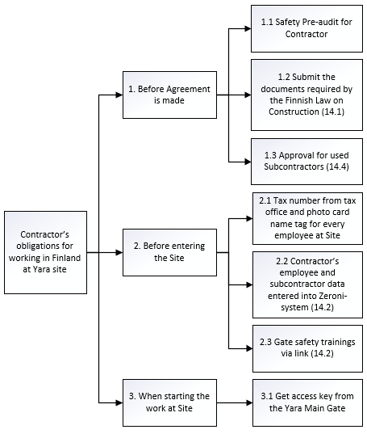

The following documents are a part of this attachment 14:

|  |  |
| --- | --- |
| Attachment 14.1 | Document requirements of The Finnish Law on Construction |
| Attachment 14.2 | Tax number, Zeroni-system and link to Gate Safety Trainings |
| Attachment 14.4 | Applying Approval for Sub-Contractors |

# ATTACHMENT 14.1 Document requirements of the Finnish Law on Construction

The Finnish Law (1233/2006) for the use of Contractors and Orderer’s obligations to submit the required clarifications came in force on 1.1.2007. This law relates only to Contractors working at Orderer's site.

To fulfil the obligations of the Law, the Contractor shall submit the following documents 1-7 to the Orderer:

1. Clarifications:
2. Finnish Tax Prepayment Register
3. register of employers
4. VAT (value-added tax) register
5. Extract from the Register of Companies
6. Clarification of tax in due
7. Clarification of the pension insurance premium
8. Clarification of the collective agreement (on terms of employment), which is followed in the Contract
9. Copy of the Company’s accident insurance
10. Copy of the Company’s Occupational Health Care Partner

All Contractors working at Yara Sites must have **a general liability insurance**. If the contract involves installation, the Contractor must also have **an installation liability insurance**, and if the contract involves lifting, **an erection all risk general insurance** is needed. If the contract involves construction works, the Contractor must take **a construction all risk insurance** (CAR), that covers also the side- and sub-contracts. The Contractor shall therefore submit the Orderer the document 8 in any case and the documents 9-11 if applicable.

1. Certificate of a general liability insurance, minimum liability 2.000.000 eur
2. Certificate of an installation liability insurance, minimum liability 2.000.000 eur
3. Certificate of an erection all risk general insurance, minimum liability 80.000 eur
4. Certificate of a construction all risk insurance (CAR), minimum liability the replacement value of the Delivery

A foreign Contractor must fulfill also the following preconditions:

1. If a foreign employer is working in Finland, they also need the following documentation i-iv.
   * 1. Certificate for an official representative in Finland: In case the employer of a posted worker does not have a business location in Finland, they shall have a representative in Finland, who is authorised to act in a court of law for the company posting workers
     2. If employees are posted workers, Certificate A1 or E101
     3. Representative for posted workers, if the work duration exceeds 10 working days within 4 months
     4. If employees are citizens of a non-EU, a non-EEA country: residence permit, passport, employment contract or another written explanation of the main terms and conditions of the employer/employee relationship in respect of the work in Finland, and Certificate A1 or E101
     5. Contract for occupational health care services in Finland
     6. Electronic declaration of posting workers to Finland sent to the Finnish Occupational Safety and Health authority

Every employee working at the Site shall carry an ID card with name, employer, photo and tax number. If the employees don’t have a Finnish tax number, please see the instructions.**The documents and certificates required above shall not be older than 3 months. The required documents shall be submitted to the purchasing contact person by email.**

# ATTACHMENT 14.2 Tax Number, Zeroni-system and link to Gate Safety Trainings

1. **Tax number and Finnish Personal Identity Code**

Every employee working on a shared construction site must, according to the Occupational Safety and Health Act, carry an identification card with their photograph and individual Finnish Tax Number. To get a Finnish Tax Number, the person must also have a Finnish personal identity code. Please go to this link to apply for them: <https://www.vero.fi/en/individuals/tax-cards-and-tax-returns/arriving_in_finland/work_in_finland/finnish-personal-identity-codes-for-workers-arriving-in-finland/> . You can contact Tax Office telephone service at +358 29 497 050. For more information about the legal requirement at Finnish construction sites, see <https://www.vero.fi/en/detailed-guidance/guidance/48791/individual-tax-numbers-and-the-public-tax-number-register2/>

1. **Zeroni-system**

Yara uses Zeroni-system to manage access control and contractor employee data. Yara grants the Contractor’s contact person(s) access to Zeroni-system. The contact person(s) gets an email and, when logging in, an SMS-message with a password. The contact person shall add their company data and their employees into Zeroni. Contractor also chains their subcontractors and adds subcontractor’s employees into Zeroni. Access keys are granted for employees, who are registered in Zeroni.

Please see the following instructions**:**

1. Log in at <https://app.zeroni.fi/login>.

To change language settings in Zeroni, choose English on the log-in screen or in your profile.

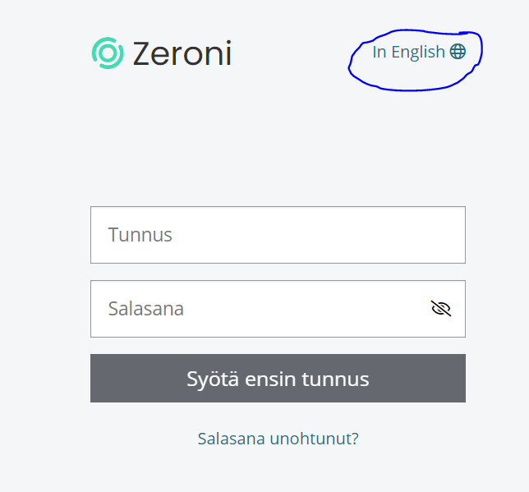

1. Go to “Sites” and choose the correct site:

Siilinjärvi: SVI00001 Siilinjärven tehtaat

Uusikaupunki: UKI00001 Uudenkaupungin tehtaat

Kokkola: KLA00001 Kokkolan tehtaat

or other site specified.

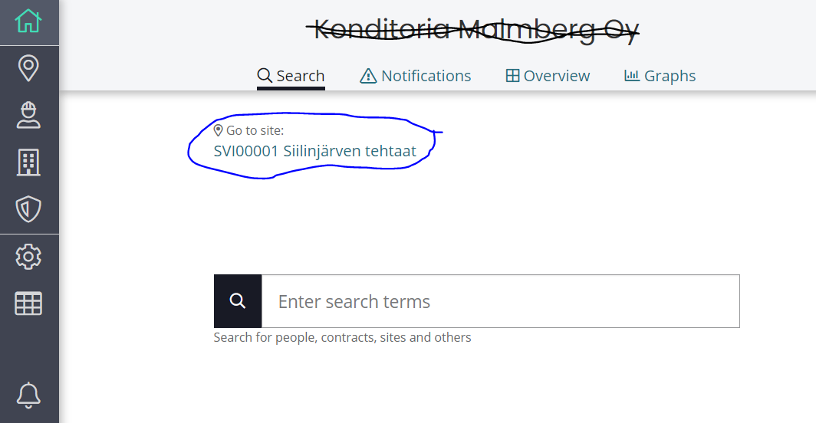

1. When you have chosen the site, go to “Persons” and “+New person”, add your employees (with the Finnish tax number).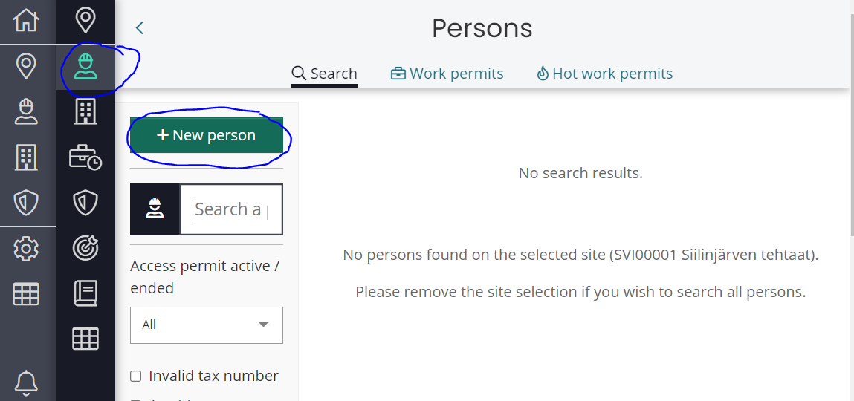

Select your contract and add your employee data. If you can’t select your contract, please contact your Yara contact person.

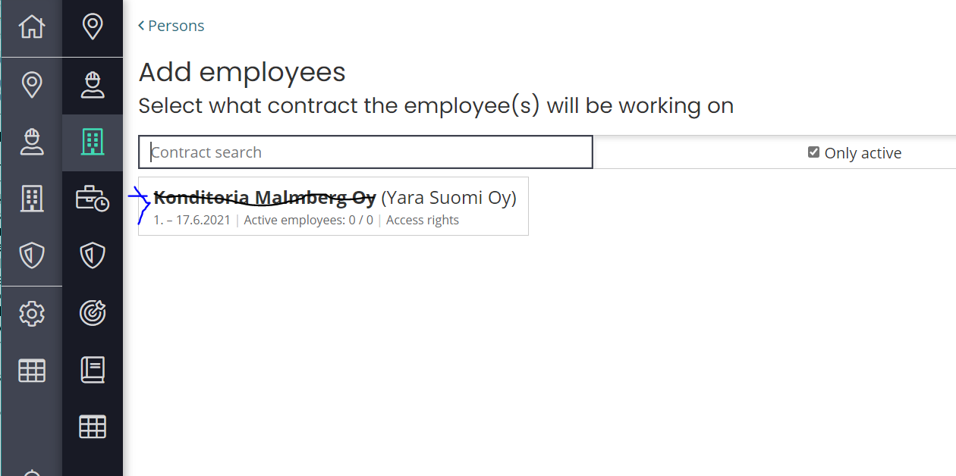

1. To add your subcontractors, go to “Contractors”, choose your company, click “Create subcontract” and add the subcontractor data and employees (with the Finnish tax number).

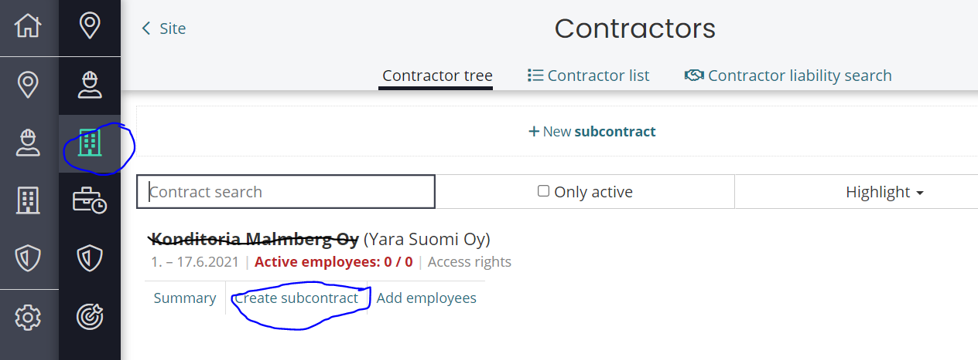

Servicedesk for Zeroni can be reached at [support@zeroni.fi](mailto:support@zeroni.fi) or by phone at 8-16 tel. +358 600 12929. Please see also the Support pages in “i”.

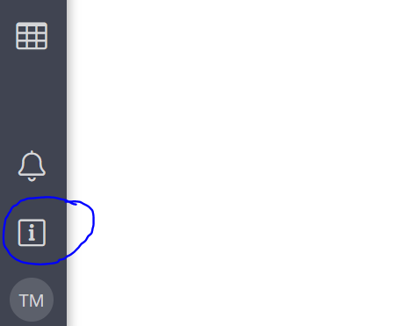

1. **Link to Gate Safety trainings**

The following link will get you to Gate Safety Training info:

<https://yara.community.gimletlms.com/en/login?returnUrl=/en>

# ATTACHMENT 14.4 Applying Orderer’s approval for Contractor's Sub-contractors.

Contractor = A contractor in a direct contractual relation to Yara

Orderer = Yara

Sub-contractor = A contractor in a direct contractual relation to the Contractor

The Contractor shall Apply for the Yara’s approval for all sub-contractors it intends to use and before they start to work at the Site by using attachment 14.4. Any chaining of sub-contractors requires always separate negotiations with the Yara contact person. Yara Procurement grants the approvals for the Sub-contractors and maintains a register of the Sub-contractors approved.

The Contractor is responsible for filling in the Sub-contractor information in the attachment 14.4 and for submitting the signed form 14.4 to the purchasing contact person.

The Contractor shall enter the Sub-contractor’s company and employee data to Zeroni-system.

The Contractor is responsible for training the approved Sub-contractors the work safety guidelines according to the Agreement.

The Contractor is responsible for transferring contractual responsibilities and claims as applicable to Sub-contractors and ensures that the subcontractor passes on responsibilities in its own chain.

The Contractor guarantees, that it has both performed the document clearance required by the Finnish Law for this Sub-contractor and checked the Sub-contractor’s accident frequency rate and went through the Orderer’s safety requirements as for the acceptable tools, work permit processes and the risks in the work site with the Sub-Contractor.

The Contractor shall be responsible for filling this application for an approval for a Sub-Contractor, and shall file it signed to the purchasing contact person.

**ATTACHMENT 14.4 Applying Orderer’s approval for Contractor's Sub-contractors**

Contractor: [In a direct contractual relation to Orderer]

Project: [To which project is the approval being applied? Agreement or purchase order number]

**PRESENTATION OF SUB-CONTRACTOR**

**Sub-contractor:**

Who has ordered the work? [Fill if someone else than Contractor is the Orderer of the work, e.g when chaining)

Company

Address

VAT-number

Description and duration of the work

**Company presentation**

Number of employees and turnover:

References for Contractor:

Accident frequency rate for the last 3 years (LTI):

**Safety clearance**

The Contractor guarantees, that it has performed the safety clearance required for this Sub-contractor as for accident frequency rate, and assessed the use of this Sub-Contractor for the work site. The Contractor guarantees, that the Sub-Contractor has been informed of the following safety practices of the Orderer (please tick):

Gate safety induction and access control

Requirements for tools and their inspections

Work permit practices at the Orderer’s work site

Risks and controlling them at the work site

**Finnish Law**

The Contractor guarantees, that it has performed the document clearance required by the Finnish Law for this Sub-contractor, and that those documents fulfill the requirements of the Finnish Law. In addition the contractor guarantees, that it has checked the following requirements.

2 M€ liability insurance

      ______________________________________________

Date Signature